# 

# 

# 

# 

# 

# 

# 

# **Higgzfield - UX Redesign and Customer Journey Mapping Report**

Surprise Minds IT Consulting: Disha Prabhu and Stefanus Albert Welong

Institute of Communication, Culture, Information, and Technology, University of Toronto Mississauga

CCT341: Introduction to IT Consulting

Professor Ibrahim Munawar

April 4, 2024

1. **Introduction:**

Higgzfield is an innovative educational platform designed for children's social-emotional learning, blending storytelling with interactive tools. By harmoniously blending the art of storytelling with interactive learning tools, it engages young learners in mastering critical life skills such as empathy, emotional regulation, and effective communication. In an era where digital platforms are increasingly pivotal in educational methodologies, Higgzfield's innovative approach heralds a new chapter in nurturing emotionally intelligent and resilient future generations.

This report offers a comprehensive analysis of Higgzfield's digital platform enhancement efforts and its strategies for mapping and improving user experience. With the aim of providing actionable insights, the analysis covers a range of key areas including:

Digital Platform Enhancement: Investigating the technical and content-related updates intended to improve accessibility, engagement, and learning outcomes. This section evaluates the platform's adaptability to diverse user needs, the scalability of its infrastructure, and the effectiveness of its content delivery mechanisms.

User Experience Mapping: A detailed exploration of the user journey on Higgzfield, identifying touchpoints that significantly impact user engagement and retention. This analysis delves into the intuitiveness of the platform's navigation, the responsiveness of its design to user inputs, and the overall satisfaction of its target demographic.

Content Strategy and Educational Impact: Assessing the alignment of Higgzfield's content strategy with its educational goals. This involves examining the thematic diversity of its offerings, the pedagogical soundness of its learning activities, and the emotional and cognitive impact on its audience.

Engagement and Interaction Models: An analysis of how Higgzfield facilitates interaction between users and the platform, as well as among users themselves. This section looks into the community features, feedback mechanisms, and collaborative opportunities provided by the platform.

Technological Innovations and Future Directions: Highlighting the cutting-edge technologies Higgzfield employs to enhance learning experiences, including any use of artificial intelligence, machine learning, and interactive simulations. Future projections for the platform's growth and development are also discussed.

By synthesizing data from user surveys, platform analytics, and industry benchmarks, this report aims to offer a holistic view of Higgzfield's current state and its potential trajectory. The ultimate goal is to provide recommendations that not only address immediate areas for improvement but also strategically position Higgzfield as a leader in educational innovation for social-emotional learning.

1. **Proposal Brief: UX Redesign and Customer Journey Mapping**

Surprise Minds IT Consulting is responsible for offering suggestions to rejuvenate the Higgzfield website with a focus on improving sales and booking procedures. Our main objective is to thoroughly examine the business services, target audience, and customer requirements. Through teamwork, we will outline the customer experience from the first contact to after-sales support. The ultimate aim is to achieve smoother sales processes, a user-friendly checkout and booking system, and seamless email integration for better communication. Surprise Minds IT Consulting will offer strategic recommendations based on their grasp of the business and market conditions.

The initial project scope and expected deliverables included a UX analysis report that contains identified pain points of the Higgzfield website, detailed customer journey maps for website visits, flow optimization recommendations, functioning checkout process recommendations, and mobile-friendly responsiveness.

*March 11 Revisions:*

As of March 11, 2024, the scope has been revised by both Higgzfield and Surprise Minds IT Consulting. The new scope and expected deliverables include a detailed UX analysis report with recommendations on how to make a purchase and procure membership at Higgzfield.

*April 3 Updates:*

As of April 3, 2024, Jovita Felita is no longer a part of Surprise Minds IT Consulting. All materials done in this report were completed by the remaining members.

1. **Business and Marketing Dynamics:**

While Higgzfield is mainly marketing tools that aid in the social-emotional learning of children, the main target audience for these products is parents. All social channels associated with the organization have produced results that show there is low engagement across the board.

* Google Analytics: 50 clicks within a 30-day period
* LinkedIn: No impressions
* Instagram: Within a 90-day period, 17 accounts were reached, 12 being non-followers. The impressions on Higgzfield’s account totaled to 62, with 57 being profile visits and 5 being external link taps. The most active period for Higgzfield’s follows (and to receive impressions) is at 3 pm.

Some suggestions for how to improve the business and marketing dynamics are as follows:

* Content Strategy: Develop a comprehensive content strategy tailored to different social media platforms. This strategy should include a mix of engaging storytelling, informative posts about the importance of social-emotional learning, user-generated content featuring testimonials or success stories, and interactive activities to showcase the platform's features.
* Visual Branding: Invest in creating visually appealing and cohesive branding elements across all social media channels. This includes consistent use of colors, fonts, and imagery that reflect the playful and educational nature of Higgzfield.
* Community Engagement: Foster a sense of community among users by actively engaging with them on social media. Encourage users to share their experiences, insights, and creations related to Higgzfield, and respond promptly to comments, messages, and mentions to build rapport and loyalty.
* Influencer Partnerships: Collaborate with influencers or experts in child development, education, or parenting to amplify the reach and credibility of Higgzfield. Identify influencers whose values align with the platform's mission and encourage them to share their experiences with their followers.
* Paid Advertising: Allocate a budget for targeted paid advertising campaigns on social media platforms to reach a broader audience. Utilize demographic targeting options to reach parents, educators, and caregivers who are likely to be interested in Higgzfield's offerings.
* Analytics and Optimization: Regularly monitor and analyze social media metrics to gauge the effectiveness of marketing efforts. Identify which types of content resonate most with the audience, refine strategies based on insights gained, and continuously optimize campaigns for better performance.

1. **Preliminary Findings - Competitor’s Analysis (peekapak.com)**

Competitor: [www.peekapak.com](http://www.peekapak.com)

* Peekapak is considered a competitor to Higgzfield, as Peekapak’s product centers on Social and Emotional Learning (SEL) equipping students with skills to manage emotions, build positive relationships, and make responsible decisions (Peekapak.com).
* Being a way more established player in the market, Peekapak’s product targets both educators and parents from kindergarten to grade 5 with some extending to middle school.

Design and layout:

* Website responsiveness: the website is responsive to window resizing (although not as flexible/responsive), and is also mobile-responsive.
* Global navigation is present throughout the website, with visible consistency.

*Reflecting against Nielsen’s Heuristics*

1. Visibility of system status - Cart status is visible

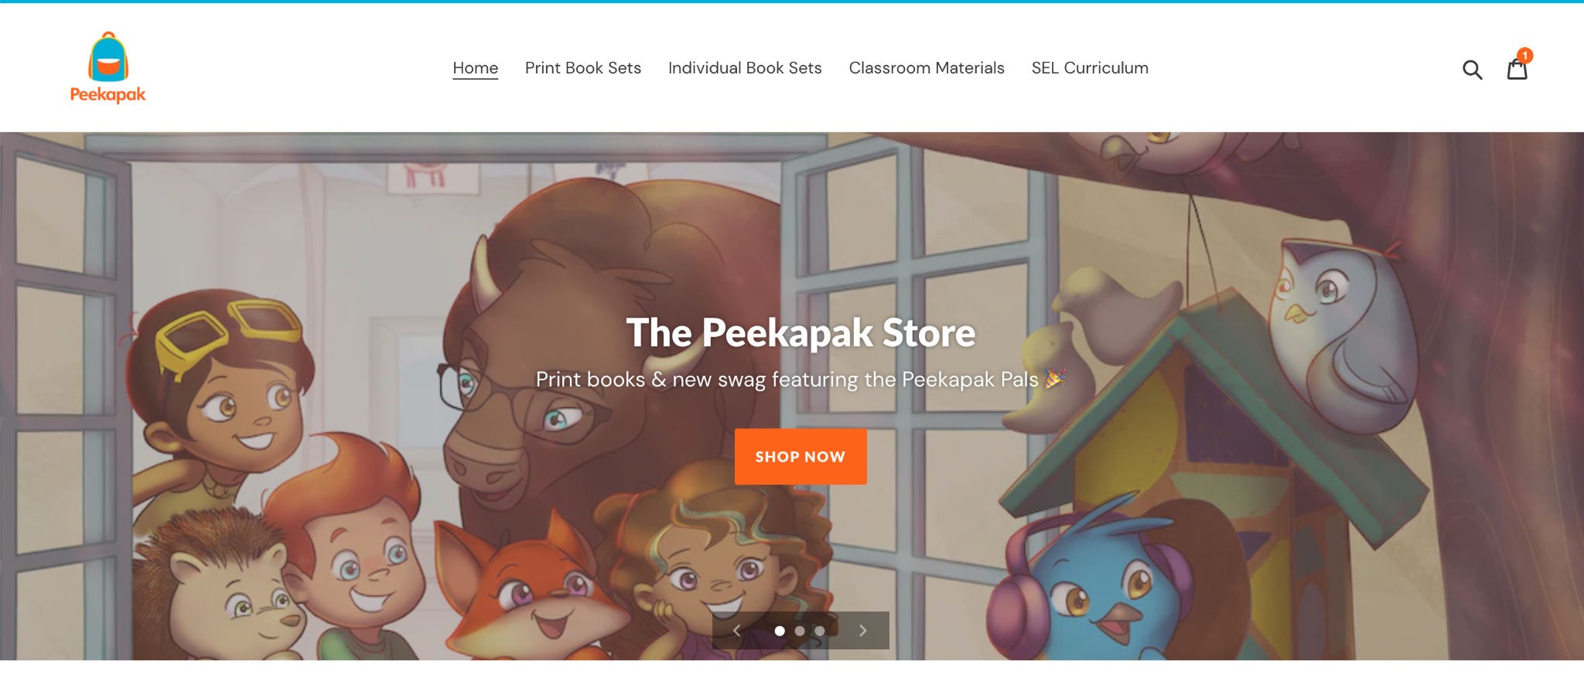

1. Match between system and the real world - Search icon, cart icon reflective of real-world objects
2. User control and freedom - several recoveries from errors to ensure user freedom (‘Continue shopping’, ‘Remove’, Cart icon)

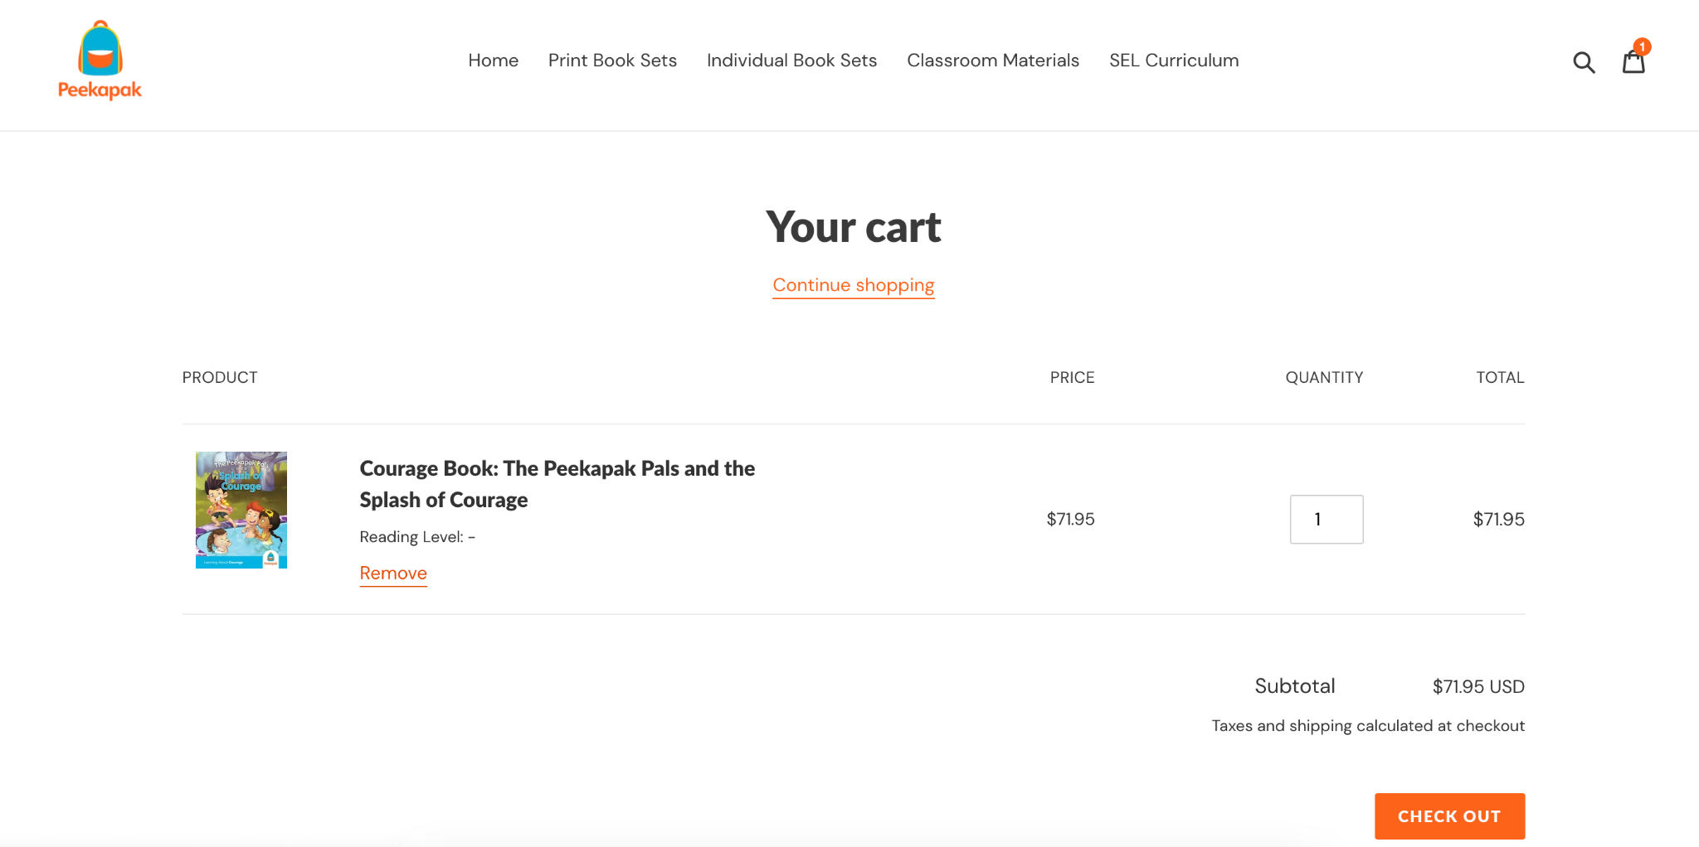

1. Consistency and standards - Global navigation is available
2. Error prevention - status updated when the new thing is added to the cart, letting the user know the course of actions

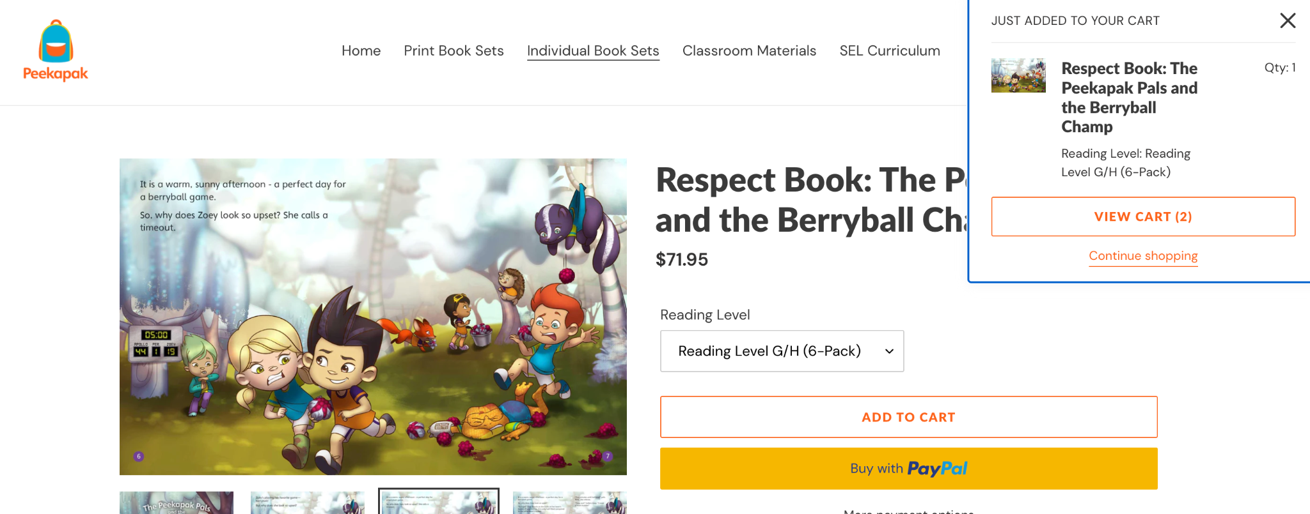

1. Recognition rather than recall - A search bar is present on the global navigation, allowing users to recall the object they’re looking to purchase without needing to remember the exact details.

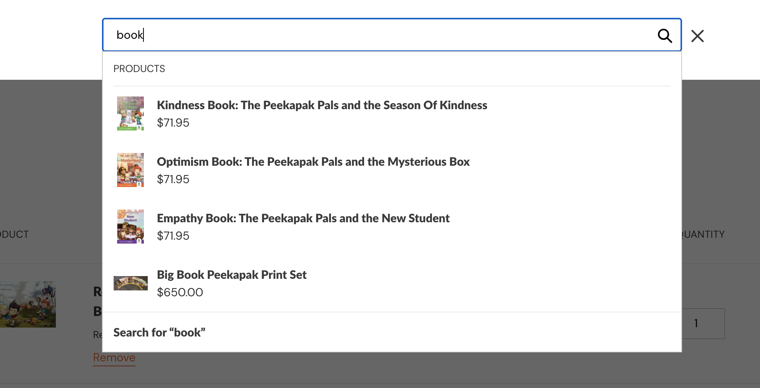

1. Flexibility and efficiency of use - Straightforward UI with the use of words more than icons to cater to both novice and experienced users.
2. Aesthetic and minimalist design - While the homepage appears crowded, the shop page is direct and simple, and is unlikely to overwhelm the users
3. Help users recognize, diagnose, and recover from errors - Peekapak fails to comply with this heuristic, as the reading level wasn’t selected but the item can still be added to the cart

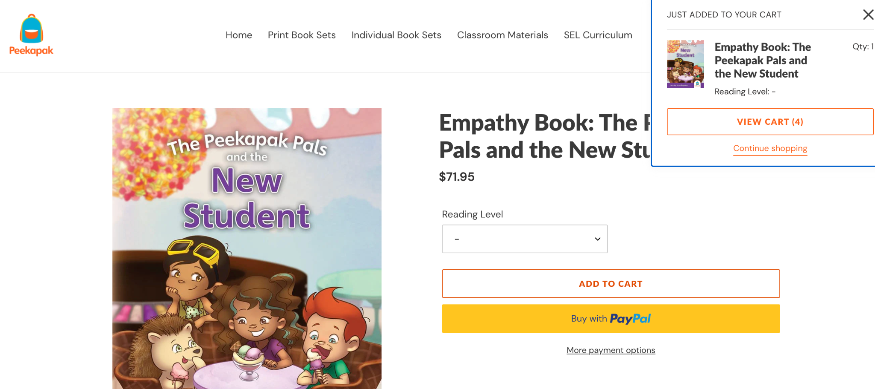

1. Help and documentation - Other than the search functionality, there isn’t much about help and documentation

Overall, after reflecting on Peekapak’s shop page against Nielsen’s 10 Heuristics, there is a lot that Higgzfield can adopt from, but also some that Higgzfield can improve on. Particularly, Peekapak fails to comply with Heuristics 8, 9, and 10. Upon traversing through Peekapak’s website, our analysis concluded that the homepage holds too much content that appears overwhelming. Nielsen’s 8th heuristic suggested that aesthetic and minimalistic design is necessary as cluttering can overwhelm the user. It is important to note that with the target audience of Higgzfield being generally parents, the design of the webpage should closely take into account the variety of technological expertise. Peekapak also failed to abide by the 9th heuristic regarding helping users recognize, diagnose, and recover from errors. In particular, when adding an item with “Reading level”, not selecting one doesn’t raise any error. This might cause further complications after purchase, and Higgzfield should take note of this to avoid the same mistake. Lastly, the 10th heuristic regarding help and documentation could be further improved. An FAQ page can be a huge aid to individuals with lingering questions before they make purchases so they can be confident when making their purchases.

1. **User Personas**

Our team has also formulated user personas and user stories to help us form the customer journey map as well as the user tasks for our usability testing. Focusing on two major tasks - Membership and Purchase - we formulated 3 user personas for each task; one for membership, one for book purchase, and another for merchandise purchase.

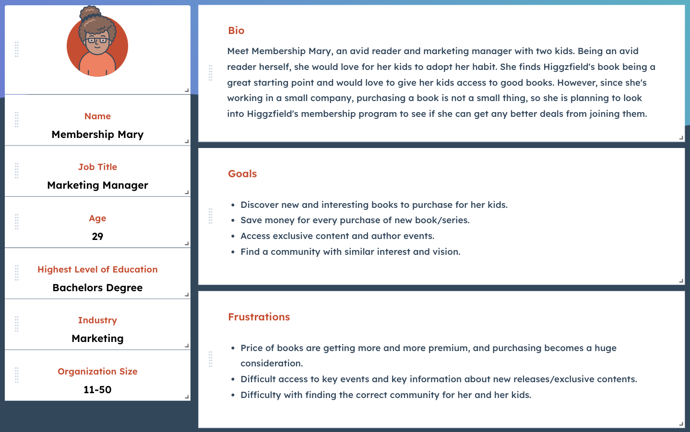

Membership Mary is an avid reader who wants her kids to follow suit, satisfied with Higgzfield’s vision. Mary wants to save money on books that she will purchase and wants to join the Higgzfield Club membership program to get discounts and access exclusive content, while also connecting with fellow book lovers.

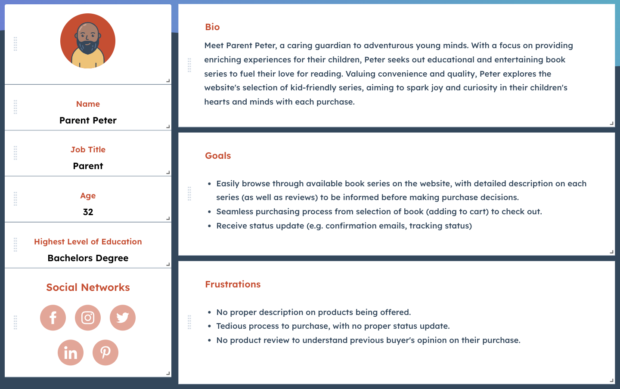

Parent Peter wants to find a book series for his kids. He wants to easily browse available book series and find details on each series and previous customer reviews. Peter also wants the purchasing process to be seamless, and receive real-time status updates from purchasing confirmation to shipment/delivery tracking.

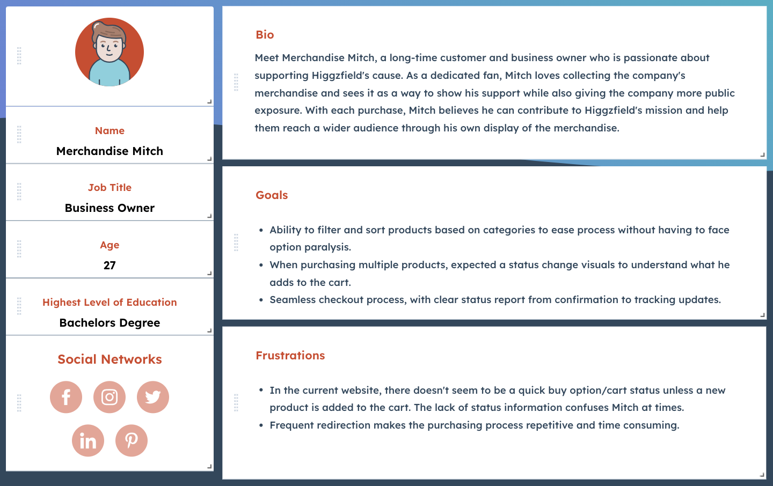

Merchandise Mitch is looking to purchase new Higgzfield merchandise. He wants to purchase several pieces of merchandise to share with his niece and nephews to help Higgzfield gain exposure.

1. **User Experience Map (Customer Journey and Pain Points Mapping)**

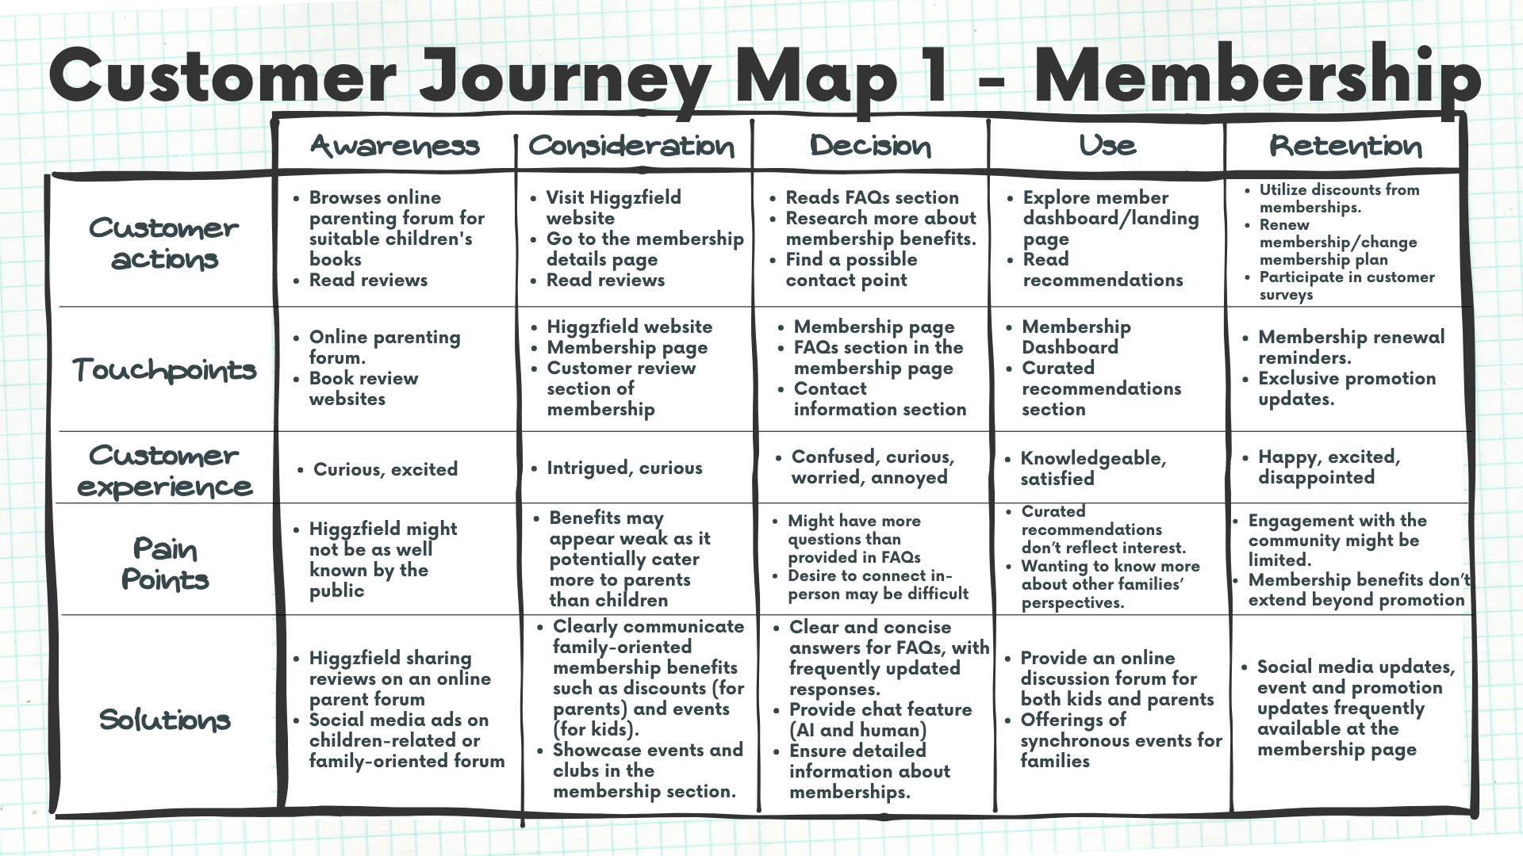

*Key Summary of Membership Journey:*

* In this journey, the customer tries to get into a membership with Higgzfield.
* The journey spans from finding out about Higgzfield to being active and renewing memberships.
* Key assumptions on what is available on the membership page:
  + A membership plan that is subscription-based, with benefits listed.
  + An FAQ section for common questions about the membership.
  + A review section for potential members to read the reviews from existing members/previous clients.
* Key solutions/suggestions:
  + Higgzfield should proactively promote their brand in online forums to make them known in the community of interest
  + Higgzfield should provide a discussion board or forum for members to interact, while also occasionally hosting events forming an interest-based community.
  + Higgzfield should be easily accessible and responsive to answer specific questions (e.g., chatbot, customer service calls, responsive emails, etc.)
  + Make use of social media to actively promote their brand, product, and events.
  + Higgzfield should provide a discussion board or forum for members to interact, while also occasionally hosting events forming an interest-based community.
  + Higgzfield should be easily accessible and responsive to answer specific questions (e.g., chatbot, customer service calls, responsive emails, etc.)
  + Make use of social media to actively promote their brand, product, and events.

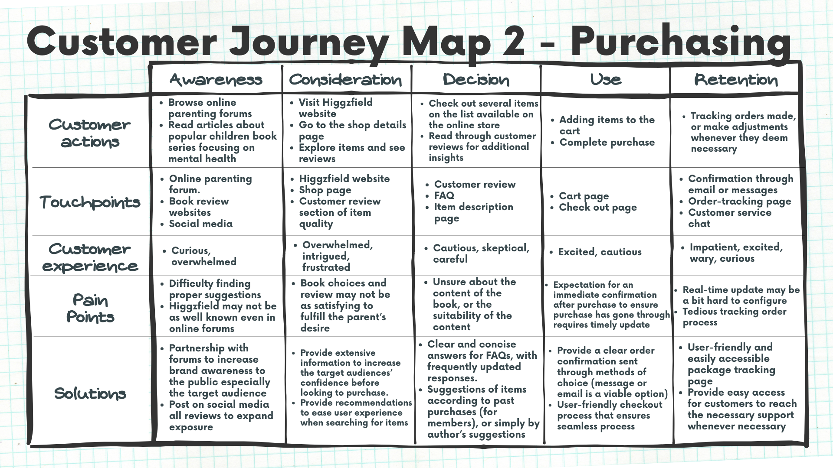

*Key Summary of Purchasing Journey:*

* In this journey, the customer is trying to purchase a book/book series with Higgzfield.
* The journey spans from going to Higgzfield’s website to purchasing the product and receiving the proper verification (either through email or other confirmation methods).
* Key assumptions on what is available on the purchasing page:
  + A list (any form column, or block) of products.
  + Local navigation such as search bar, filtering, and listing options.
  + A cart icon to show the status of the cart (number of items added status)
  + Proceed to the payment page.
  + Reviews and descriptions of each product when every product is clicked
* Key solutions/suggestions:
  + Combine the merchandise and book series page, separated with a filtering function to filter according to the type of the product.
  + A status update (a cart status on the top of the page that is preferably following the scrolling of the user → uses the absolute position for CSS styling)
    - This allows for the web page to abide by standards of design principles such as recovery from errors and visible system status.
  + A clear status update on confirmation upon purchases, with a history of purchases if users are logged in (catering to existing members as part of their benefit).

1. **User Testing and Survey**

Other than conducting an internal review of the Higgzfield website, Surprise Minds IT Consulting decided to do an external survey to rate the usability of the website. Even though the target audience for Higgzfield is parents of young children, our survey group consisted of university students who were told to only conduct the necessary functions to operate the website. Out of 13 students, 38.5% stated that it was easy to navigate the website, elaborating that because it was only one page, there was not much navigating to do. Some findings that testers commented on was the overall aesthetic of the website, such as the font, colours, and designs. Their eyes were also drawn to the merchandise for sale.

Some difficulties that the testers mentioned were that there was a lack of mobile responsiveness, and that they were endlessly scrolling on the singular landing page. There was also no global navigation/menu bar/drop down menu to sift through the sub pages. When asked if they understood what product was being offered, 38.5% stated that they did not understand. One tester tried to make a purchase, stating that they “can't click on the picture of the book to view it and it forces you to click the link below it which is not very intuitive. In addition, it was hard to navigate the testimonies because I did not see the left and right arrows at first which were a similar color to the background. When checking out, I could not find the cart button after I added a hoodie and the only way I got it to show again was by adding another one”.

Our team also conducted usability testing to further understand the possible interactions given the limited amount of information about the website’s current success. We tested the website against the scenario that we have created concerning our previously formulated user stories and customer journey map.

*User tasks:*

* General tasks:
  + Find and explore the homepage
  + View company profile (about us or company information)
  + Search for modes of communication (emails, phone number, chatbot, etc. if applicable)
  + Find customer reviews on the company
  + Find the page for membership or store according to needs
* Membership test:
  + Navigate to the membership page from the homepage.
  + Find information on the benefits of Higgzfield’s membership.
  + Find the pricing of the membership, as well as payment methods.
  + Sign up for membership
* Purchasing books/merchandise:
  + Navigate to the store page from the homepage/membership page.
  + Utilize the filter function to filter out only books/merchandise according to the user's story
  + Check item descriptions and reviews (for books: book description, for merchandise: size, material)
  + Add an item to the cart
  + Remove an item from the cart
  + View cart
  + Make purchase and payment
  + Find confirmation of purchase

*Test Script:*

**Scenario**: You are a parent with kids. You hear from fellow parents that giving your children books about emotional and social learning boosts your children’s well-being. You are curious to know more about the company and possibly looking to purchase the product.

1. You discovered the company website at higgzfield.com and you decided to visit the website
2. You arrived at the landing page, and you are looking to see the details of the products they offer
3. You hesitated and decided to check for some reviews on the website
4. You proceed to purchase a book series

**Now assume you want to buy the merchandise instead**

1. Upon arriving at the website, you decided to look for the company’s merchandise
2. You want to buy one Boson fleece hoodie for your kids
3. After further consideration, you decided to cancel that and change it to a Buzzy fleece hoodie for kids
4. You like your choice and decide to check out

**Now assume you are looking to join the Higgzfield membership**

1. Upon landing on the website, you look for the membership page to register yourself as a member
2. You sign up for a membership

*Testing Demographics:*The testing is being conducted on 6 individuals of age group 17-28.

* Their level of technological expertise can be considered as medium to high
* Demographics: Asia, Europe, Canada → to potentially reach a global scale but the focus is still primarily on International standards of web page design.

*Findings:*

Upon conducting usability testing on 6 individuals, there are several findings worth reviewing: (blue - general, orange - membership, green - book, red - merchandise)

* Testers appear confused when looking to navigate to the page to find other pages such as company information (about)
* The tester commented on the fact that the page is only a one-pager with no global navigation
* The tester finds the review section (families, doctors, kids, parents, educators) informative
* Frustration is visible from the inability to search for things on the website
* The “Membership” word cannot be discovered, the tester assumed that it has something to do with the email list.
* Joining the email list requires approval with no certainty hence causing the tester to appear frustrated (screenshot attached for reference)

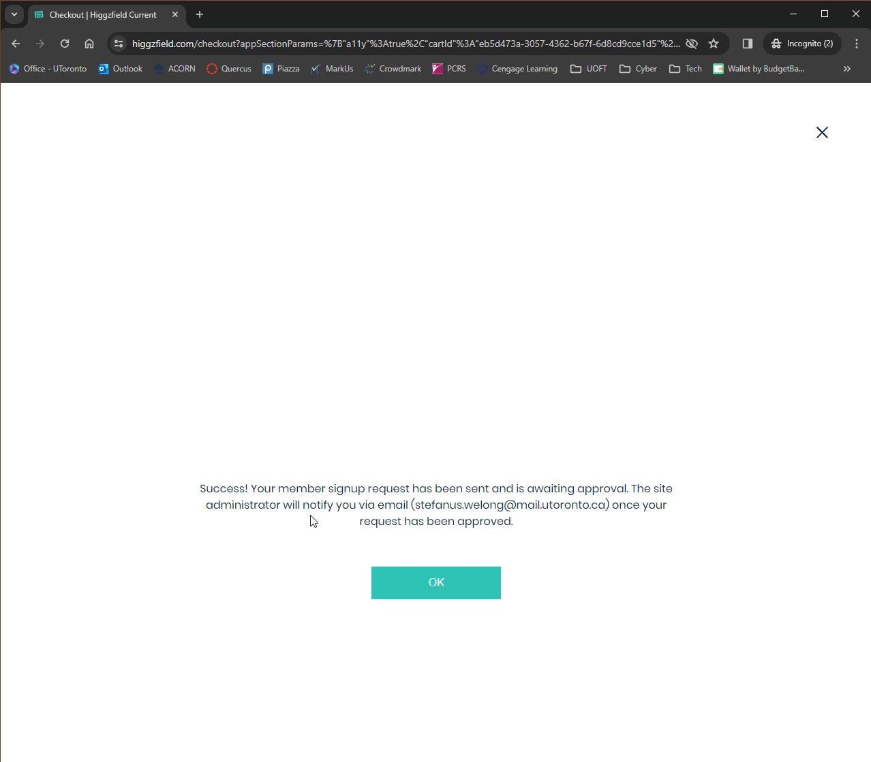

* The purchase of books is being redirected to Amazon (a third-party platform)
  + Amazon UI onwards
* No available system status visibility (cannot see what has been added to the cart once the cart tab is closed)
* Inability to cancel a product with ease, have to go to the checkout page to remove an item
* Information on merchandise products is visible, but no review section can be found
* The checkout process is simple and intuitive for the merchandise, with the ability to recover from errors and easy navigation (going back to cart review and also continue browsing the online store)

1. **Analysis using Nielsen’s Heuristics and Wicken’s Principles**

*Nielsen’s Heuristics*

* + Visibility of system status: Users should always be informed about what is happening within the system through appropriate feedback. Through the purchasing function on the website, customers are unable to see the status of their cart.
  + Match between system and the real world: The system should use language and concepts familiar to the user, rather than system-oriented terms. Language used on the website is consistent with the brand image. However, testers also mentioned that they would like more information on merchandise on what they are buying.
  + User control and freedom: One tester expressed the option to add an exit (X) on merchandise, suggesting a “Quick View” function.
  + Consistency and standards: Users should be able to easily navigate and exit the system, especially if they make a mistake. The system should follow established conventions and standards to avoid confusion. Having subpages and navigation (similar to other websites) would be beneficial.
  + Error prevention: Design should prevent errors whenever possible, rather than relying solely on error messages to correct them. There are not many error messages, but the design could be improved to help create a better experience for customers.
  + Recognition rather than recall: Users should not have to remember information from one part of the interface to another. Information should be visible and easily retrievable. This is essential for the “making a purchase” function, where customers are unable to view their cart.
  + Flexibility and efficiency of use: Experienced users should be able to accomplish tasks efficiently, with shortcuts and accelerators provided when appropriate. Because there is difficulty navigating the pages, subpages would aid in helping customers focus on their needs when coming to the website.
  + Aesthetic and minimalist design: The interface should be clean and free from unnecessary clutter, focusing on essential elements for user tasks. Many testers expressed that the interface is eye-catching.
  + Help users recognize, diagnose, and recover from errors: Error messages, if added to the website, should be clear, precise, and suggest constructive solutions to the user.
  + Help and documentation: If help documentation is necessary, it should be easily accessible, searchable, and focused on the user's tasks.

*Wicken’s Principles*

* + Perceptual principles: Understanding how users perceive visual information and how it can be presented effectively in interfaces. With Higgzfield’s layout, having everything on one page may be confusing.
  + Attentional principles: Designing interfaces to manage users' attention effectively, minimizing distractions and highlighting important information. Having subpages would help focus specific information on specific pages.
  + Memory principles: Considering how users encode, store, and retrieve information in interfaces, and designing for ease of recall and recognition when navigating Higgzfield’s website.
  + Feedback and error handling: Applying principles of feedback and error prevention based on cognitive processes to improve user experience. Many testers expressed that they would have to scroll if on mobile, which is why having subpages would be beneficial.
  + Mental models: Designing interfaces for the Higgzfield website that align with users' mental models and cognitive schemas to enhance usability and learnability.

1. **Recommendations**

For optimal user experience (UX), it is important to prioritize certain key elements across the website. Among these, global navigation stands out as the cornerstone of effective browsing. Seamless navigation facilitates users in swiftly accessing desired content, thereby enhancing engagement and satisfaction. Furthermore, the visibility of system status, particularly on crucial pages like the shop page, is necessary. Ensuring users are promptly informed about their current interactions or transactions fosters confidence and streamlines their browsing experience.

To streamline user interaction and facilitate easy access to essential features, it is advisable to dedicate separate pages to key functionalities. By offering distinct pages for Shop, Membership, About Us, and Contact Us, users can navigate directly to their desired section with ease. This organizational structure not only enhances user convenience but also provides a clear and intuitive browsing journey, thereby improving overall satisfaction and usability. Additionally, expanding login/sign-up accessibility beyond just checkout processes can encourage user engagement and foster a sense of community within the platform.

In broader recommendations, leveraging social media platforms can significantly amplify brand exposure and reach. However, it's essential to critically assess the impact of current strategies. While incorporating Instagram into the digital ecosystem is a positive step, its effectiveness in raising brand awareness appears limited. By refining content strategies, engaging with users more actively, and exploring diverse social media channels, the brand can harness the full potential of social media to bolster its online presence and engage with a wider audience effectively.

1. **Conclusion**

The analysis conducted by Surprise Minds IT Consulting sheds light on the critical areas requiring enhancement within the Higgzfield website to optimize user experience and bolster its market presence. Through rigorous evaluation utilizing Nielsen's Heuristics and Wicken's Principles, key insights were discussed, identifying pain points and opportunities for improvement. From the lack of mobile responsiveness to the absence of clear navigation cues, these findings underscore the importance of aligning design elements with user expectations and cognitive processes. Moving forward, implementing the recommended strategies, such as introducing global navigation, refining content strategies, and diversifying social media engagement, holds the promise of not only addressing existing usability challenges but also positioning Higgzfield as a leader in educational innovation for social-emotional learning.

Furthermore, the collaborative effort between Surprise Minds IT Consulting and Higgzfield exemplifies a proactive approach towards continuous improvement and customer-centricity. By prioritizing user feedback and leveraging industry best practices, Higgzfield is poised to enhance its digital platform's functionality, accessibility, and overall appeal. With a renewed focus on seamless navigation, transparent feedback mechanisms, and strategic social media engagement, Higgzfield can forge stronger connections with its target audience, driving sustainable growth and fostering a vibrant community dedicated to children's social-emotional learning journey.